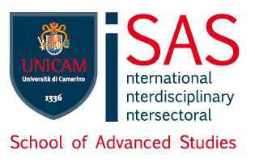

Università degli Studi di Camerino
School of Advanced Studies
Doctoral course in

___________________________________________________
Curriculum

___________________________________________________

Cycle _________
Title

PhD Student
_________________

Supervisor
______________________
Co-supervisor
______________________

Coordinator of the PhD Programme
______________________
Date of award __/__/____
Abstract (EN)
________________________________________________________________________________________________________________________________________________________________________________________________________________________________________________________________________________________________________________________________________________________________________________________________________________________________________________________________________________________________________________________________________________________________________________________________________________________________________________________________________________________________________________________________________________________________________________________________________________________________________________________________________________________________________________________________________________________________________________________________________________________________________________________________________________________________________________________________________________________________________________________________________________________________________________________________________________________________________________________________________________________________________________________________________________________________________________________________________________________________________________________________________________________________________________________________________________________________________________________________________________________________________________________________________________
Key words (EN)
________; _________; ___________; __________
Scientific field of the dissertation (SSD):
___________
School the Ph.D. Student belongs to at UNICAM:
___________ OR
University where the Ph.D. students carried out his/her program:
___________
Other (e.g. Co-funding Programs or Institutions): ___________

