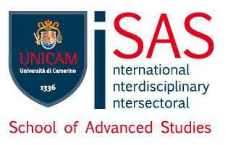

Università degli studi di Camerino

School of Advanced Studies

Doctoral course in

___________________________________________________

_____________ cycle

TITLE THESIS

PhD Student Supervisors

_________________ ________________

Co- supervisors

________________

